**一、看图写数**

[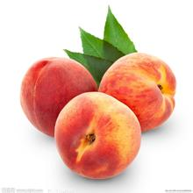](http://image.baidu.com/i?ct=503316480%26z=%26tn=baiduimagedetail%26ipn=d%26word=%E6%A1%83%E5%AD%90%26step_word=%E6%A1%83%E5%AD%90%26ie=utf-8%26in=8521%26cl=%26lm=%26st=%26cs=4097935188,1785234876%26os=4200027620,9383922%26pn=9%26rn=1%26di=27823207280%26ln=1000%26fr=%26%26fmq=1411029513000_R%26ic=%26s=%26se=%26sme=0%26tab=%26width=%26height=%26face=%26is=%26istype=%26ist=%26jit=%26objurl=http%3A%2F%2Fpic21.nipic.com%2F20120513%2F2786001_162420950000_2.jpg) [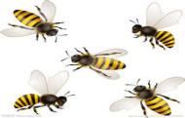](http://image.baidu.com/i?ct=503316480%26z=%26tn=baiduimagedetail%26ipn=d%26word=%E8%9C%9C%E8%9C%82%26step_word=%26ie=utf-8%26in=18339%26cl=2%26lm=-1%26st=-1%26cs=4045994414,3306618139%26os=4067562462,2535180%26pn=31%26rn=1%26di=165914096810%26ln=1000%26fr=%26%26fmq=1411029571625_R%26ic=0%26s=%26se=1%26sme=0%26tab=%26width=%26height=%26face=0%26is=%26istype=2%26ist=%26jit=%26objurl=http%3A%2F%2Fpic26.nipic.com%2F20121221%2F2531170_100900380000_2.jpg) [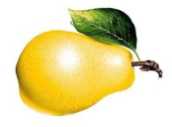](http://image.baidu.com/i?ct=503316480%26z=%26tn=baiduimagedetail%26ipn=d%26word=%E6%A2%A8%26step_word=%26ie=utf-8%26in=19362%26cl=2%26lm=-1%26st=-1%26cs=1528000378,2318067991%26os=4124152949,2588159908%26pn=15%26rn=1%26di=43622721719060%26ln=1000%26fr=%26%26fmq=1411029723978_R%26ic=0%26s=%26se=1%26sme=0%26tab=%26width=%26height=%26face=0%26is=%26istype=2%26ist=%26jit=%26objurl=http%3A%2F%2Fwww.qhdtw.com%2Fuploadfile%2Fjpg%2F2008-12%2F20081210151043750.jpg) [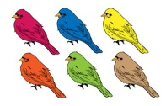](http://image.baidu.com/i?ct=503316480%26z=%26tn=baiduimagedetail%26ipn=d%26word=%E5%B0%8F%E9%B8%9F%26step_word=%26ie=utf-8%26in=3909%26cl=2%26lm=-1%26st=-1%26cs=2953908053,1947661353%26os=2628955520,838299304%26pn=26%26rn=1%26di=83471805890%26ln=1000%26fr=%26%26fmq=1411029782801_R%26ic=0%26s=%26se=1%26sme=0%26tab=%26width=%26height=%26face=0%26is=%26istype=2%26ist=%26jit=%26objurl=http%3A%2F%2Fimg.sootuu.com%2FExchange%2F2010%2F11%2F22%2F201011225351833.jpg) [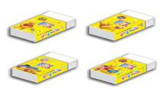](http://image.baidu.com/i?ct=503316480%26z=%26tn=baiduimagedetail%26ipn=d%26word=%E6%A9%A1%E7%9A%AE%26step_word=%26ie=utf-8%26in=2397%26cl=%26lm=%26st=%26cs=3454086731,94256016%26os=3412839438,1975902269%26pn=3%26rn=1%26di=34372886790%26ln=1000%26fr=%26%26fmq=1411030164854_R%26ic=%26s=%26se=%26sme=0%26tab=%26width=%26height=%26face=%26is=%26istype=%26ist=%26jit=%26objurl=http%3A%2F%2Fyc8899.tw.rakuten-static.com%2F990608-35.jpg)

[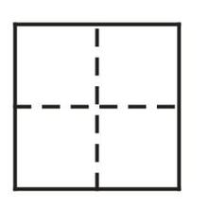](http://image.baidu.com/i?ct=503316480%26z=%26tn=baiduimagedetail%26ipn=d%26word=%E7%94%B0%E5%AD%97%E6%A0%BC%26step_word=%26ie=utf-8%26in=23558%26cl=2%26lm=-1%26st=-1%26cs=56335098,238871653%26os=4243817941,1920750640%26pn=1%26rn=1%26di=157402850660%26ln=1000%26fr=%26%26fmq=1411030199011_R%26ic=0%26s=%26se=1%26sme=0%26tab=%26width=%26height=%26face=0%26is=%26istype=2%26ist=%26jit=%26objurl=http%3A%2F%2Fwenwen.soso.com%2Fp%2F20110521%2F20110521150346-844988269.jpg) [](http://image.baidu.com/i?ct=503316480%26z=%26tn=baiduimagedetail%26ipn=d%26word=%E7%94%B0%E5%AD%97%E6%A0%BC%26step_word=%26ie=utf-8%26in=23558%26cl=2%26lm=-1%26st=-1%26cs=56335098,238871653%26os=4243817941,1920750640%26pn=1%26rn=1%26di=157402850660%26ln=1000%26fr=%26%26fmq=1411030199011_R%26ic=0%26s=%26se=1%26sme=0%26tab=%26width=%26height=%26face=0%26is=%26istype=2%26ist=%26jit=%26objurl=http%3A%2F%2Fwenwen.soso.com%2Fp%2F20110521%2F20110521150346-844988269.jpg) [](http://image.baidu.com/i?ct=503316480%26z=%26tn=baiduimagedetail%26ipn=d%26word=%E7%94%B0%E5%AD%97%E6%A0%BC%26step_word=%26ie=utf-8%26in=23558%26cl=2%26lm=-1%26st=-1%26cs=56335098,238871653%26os=4243817941,1920750640%26pn=1%26rn=1%26di=157402850660%26ln=1000%26fr=%26%26fmq=1411030199011_R%26ic=0%26s=%26se=1%26sme=0%26tab=%26width=%26height=%26face=0%26is=%26istype=2%26ist=%26jit=%26objurl=http%3A%2F%2Fwenwen.soso.com%2Fp%2F20110521%2F20110521150346-844988269.jpg) [](http://image.baidu.com/i?ct=503316480%26z=%26tn=baiduimagedetail%26ipn=d%26word=%E7%94%B0%E5%AD%97%E6%A0%BC%26step_word=%26ie=utf-8%26in=23558%26cl=2%26lm=-1%26st=-1%26cs=56335098,238871653%26os=4243817941,1920750640%26pn=1%26rn=1%26di=157402850660%26ln=1000%26fr=%26%26fmq=1411030199011_R%26ic=0%26s=%26se=1%26sme=0%26tab=%26width=%26height=%26face=0%26is=%26istype=2%26ist=%26jit=%26objurl=http%3A%2F%2Fwenwen.soso.com%2Fp%2F20110521%2F20110521150346-844988269.jpg) [](http://image.baidu.com/i?ct=503316480%26z=%26tn=baiduimagedetail%26ipn=d%26word=%E7%94%B0%E5%AD%97%E6%A0%BC%26step_word=%26ie=utf-8%26in=23558%26cl=2%26lm=-1%26st=-1%26cs=56335098,238871653%26os=4243817941,1920750640%26pn=1%26rn=1%26di=157402850660%26ln=1000%26fr=%26%26fmq=1411030199011_R%26ic=0%26s=%26se=1%26sme=0%26tab=%26width=%26height=%26face=0%26is=%26istype=2%26ist=%26jit=%26objurl=http%3A%2F%2Fwenwen.soso.com%2Fp%2F20110521%2F20110521150346-844988269.jpg)

**二、按要求填空**

|  |
| --- |
| ○○○○○○○○○（ ）  □□□□□□ （ ） |

|  |
| --- |
| △△△△△△ （ ）  ☆☆☆☆☆☆☆☆☆☆（ ） |

（ ）比（ ）多 （ ）比（ ）少

[](http://image.baidu.com/i?ct=503316480%26z=%26tn=baiduimagedetail%26ipn=d%26word=%E7%94%B0%E5%AD%97%E6%A0%BC%26step_word=%26ie=utf-8%26in=23558%26cl=2%26lm=-1%26st=-1%26cs=56335098,238871653%26os=4243817941,1920750640%26pn=1%26rn=1%26di=157402850660%26ln=1000%26fr=%26%26fmq=1411030199011_R%26ic=0%26s=%26se=1%26sme=0%26tab=%26width=%26height=%26face=0%26is=%26istype=2%26ist=%26jit=%26objurl=http%3A%2F%2Fwenwen.soso.com%2Fp%2F20110521%2F20110521150346-844988269.jpg)○[](http://image.baidu.com/i?ct=503316480%26z=%26tn=baiduimagedetail%26ipn=d%26word=%E7%94%B0%E5%AD%97%E6%A0%BC%26step_word=%26ie=utf-8%26in=23558%26cl=2%26lm=-1%26st=-1%26cs=56335098,238871653%26os=4243817941,1920750640%26pn=1%26rn=1%26di=157402850660%26ln=1000%26fr=%26%26fmq=1411030199011_R%26ic=0%26s=%26se=1%26sme=0%26tab=%26width=%26height=%26face=0%26is=%26istype=2%26ist=%26jit=%26objurl=http%3A%2F%2Fwenwen.soso.com%2Fp%2F20110521%2F20110521150346-844988269.jpg) [](http://image.baidu.com/i?ct=503316480%26z=%26tn=baiduimagedetail%26ipn=d%26word=%E7%94%B0%E5%AD%97%E6%A0%BC%26step_word=%26ie=utf-8%26in=23558%26cl=2%26lm=-1%26st=-1%26cs=56335098,238871653%26os=4243817941,1920750640%26pn=1%26rn=1%26di=157402850660%26ln=1000%26fr=%26%26fmq=1411030199011_R%26ic=0%26s=%26se=1%26sme=0%26tab=%26width=%26height=%26face=0%26is=%26istype=2%26ist=%26jit=%26objurl=http%3A%2F%2Fwenwen.soso.com%2Fp%2F20110521%2F20110521150346-844988269.jpg)○ [](http://image.baidu.com/i?ct=503316480%26z=%26tn=baiduimagedetail%26ipn=d%26word=%E7%94%B0%E5%AD%97%E6%A0%BC%26step_word=%26ie=utf-8%26in=23558%26cl=2%26lm=-1%26st=-1%26cs=56335098,238871653%26os=4243817941,1920750640%26pn=1%26rn=1%26di=157402850660%26ln=1000%26fr=%26%26fmq=1411030199011_R%26ic=0%26s=%26se=1%26sme=0%26tab=%26width=%26height=%26face=0%26is=%26istype=2%26ist=%26jit=%26objurl=http%3A%2F%2Fwenwen.soso.com%2Fp%2F20110521%2F20110521150346-844988269.jpg)

**1**

**2**

**3**

**4**

**5**

**6**

**7**

**8**

**9**

**10**

**三、数一数，连一连。**

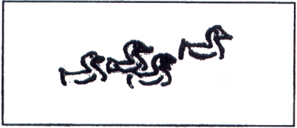 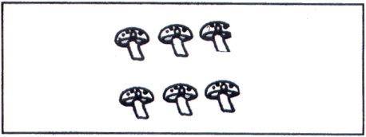

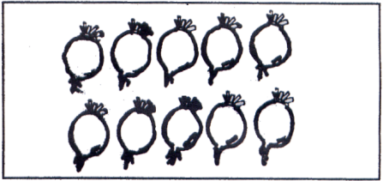

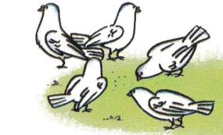

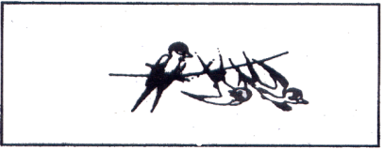 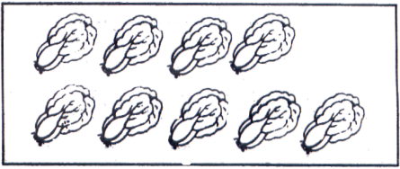

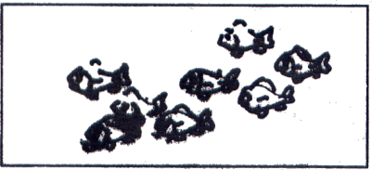 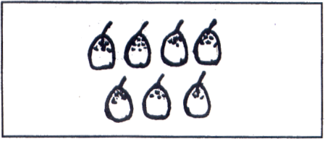

1. **按数的顺序填空。**

http://www.cnshuxue.com/upload/2006-5-4/20065413134996131.gifhttp://www.cnshuxue.com/upload/2006-5-4/20065413135556218.gif

1. **在 里填上“＞”“＜”或“=”。（6分）**

**2 5 0 1 3 3 10 4 2 7 6 10**

**7 6 5 3 8 4 5 9 8 8 4 0**

**六、看数圈图（共6分）**

|  |  |  |  |  |  |
| --- | --- | --- | --- | --- | --- |
| 9 |  | 3 |  | 7 |  |
| 8 |  | 4 |  | 5 |  |

**七、数一数，画一画**

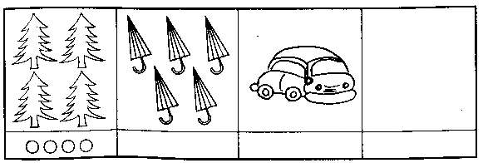 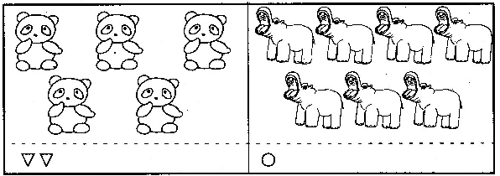

1. **根据每张图的数字，画上缺少的图形**

○○○○

8

* ☆ ☆

7

* □

10 □ □

□

* △ △ △

6

**九、十的分解**

**8 10 2 7 3 1 9**

5 4 5 9 4 5 3 4 3

**十、几个与第几个**

**1、按要求涂色（4%）**

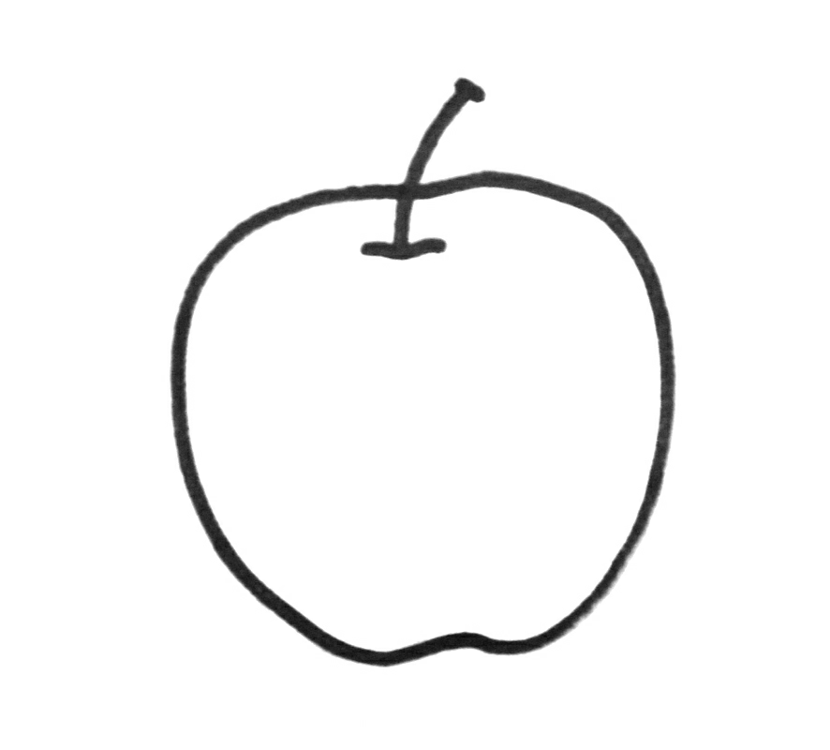

**（1）从前往后数第2个涂上颜色**

**（2）从后往前数2个涂上颜色**



**2、按要求填数（10%）**

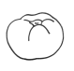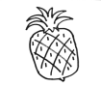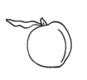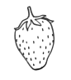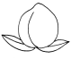



**（1）从前数起 在第（ ）个，从后数起 在第（ ）个。**

**（2） 的前边有（ ）个水果， 的后边有（ ）个水果。**

**（3）一共有（ ）个水果。**