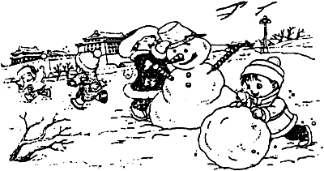【看图写话专项练习】**绿色圃中小学教育http://www.LSPJY.com**

1 时 间：

地 点：

人 物：

干什么：

|  |  |  |  |  |  |  |  |  |  |  |  |
| --- | --- | --- | --- | --- | --- | --- | --- | --- | --- | --- | --- |
|  |  |  |  |  |  |  |  |  |  |  |  |
|  |  |  |  |  |  |  |  |  |  |  |  |
|  |  |  |  |  |  |  |  |  |  |  |  |
|  |  |  |  |  |  |  |  |  |  |  |  |
|  |  |  |  |  |  |  |  |  |  |  |  |

【修改后】

|  |  |  |  |  |  |  |  |  |  |  |  |
| --- | --- | --- | --- | --- | --- | --- | --- | --- | --- | --- | --- |
|  |  |  |  |  |  |  |  |  |  |  |  |
|  |  |  |  |  |  |  |  |  |  |  |  |
|  |  |  |  |  |  |  |  |  |  |  |  |
|  |  |  |  |  |  |  |  |  |  |  |  |
|  |  |  |  |  |  |  |  |  |  |  |  |

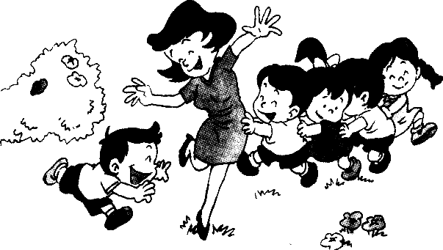2 时 间：

地 点：

人 物：

干什么：

心 情：

|  |  |  |  |  |  |  |  |  |  |  |  |
| --- | --- | --- | --- | --- | --- | --- | --- | --- | --- | --- | --- |
|  |  |  |  |  |  |  |  |  |  |  |  |
|  |  |  |  |  |  |  |  |  |  |  |  |
|  |  |  |  |  |  |  |  |  |  |  |  |
|  |  |  |  |  |  |  |  |  |  |  |  |
|  |  |  |  |  |  |  |  |  |  |  |  |

【修改后】

|  |  |  |  |  |  |  |  |  |  |  |  |
| --- | --- | --- | --- | --- | --- | --- | --- | --- | --- | --- | --- |
|  |  |  |  |  |  |  |  |  |  |  |  |
|  |  |  |  |  |  |  |  |  |  |  |  |
|  |  |  |  |  |  |  |  |  |  |  |  |
|  |  |  |  |  |  |  |  |  |  |  |  |
|  |  |  |  |  |  |  |  |  |  |  |  |

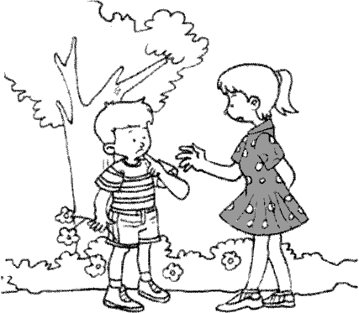【看图写话专项练习】**绿色圃中小学教育http://www.LSPJY.com**

3 时 间：

地 点：

人 物：

干什么：

|  |  |  |  |  |  |  |  |  |  |  |  |
| --- | --- | --- | --- | --- | --- | --- | --- | --- | --- | --- | --- |
|  |  |  |  |  |  |  |  |  |  |  |  |
|  |  |  |  |  |  |  |  |  |  |  |  |
|  |  |  |  |  |  |  |  |  |  |  |  |
|  |  |  |  |  |  |  |  |  |  |  |  |
|  |  |  |  |  |  |  |  |  |  |  |  |

【修改后】

|  |  |  |  |  |  |  |  |  |  |  |  |
| --- | --- | --- | --- | --- | --- | --- | --- | --- | --- | --- | --- |
|  |  |  |  |  |  |  |  |  |  |  |  |
|  |  |  |  |  |  |  |  |  |  |  |  |
|  |  |  |  |  |  |  |  |  |  |  |  |
|  |  |  |  |  |  |  |  |  |  |  |  |
|  |  |  |  |  |  |  |  |  |  |  |  |

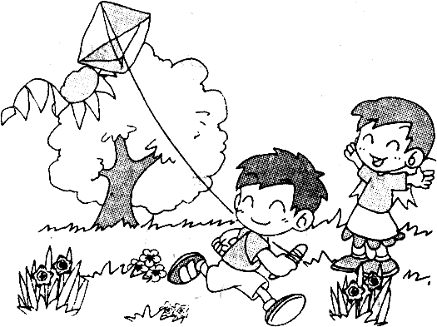4 时 间：

地 点：

人 物：

干什么：

心 情：

|  |  |  |  |  |  |  |  |  |  |  |  |
| --- | --- | --- | --- | --- | --- | --- | --- | --- | --- | --- | --- |
|  |  |  |  |  |  |  |  |  |  |  |  |
|  |  |  |  |  |  |  |  |  |  |  |  |
|  |  |  |  |  |  |  |  |  |  |  |  |
|  |  |  |  |  |  |  |  |  |  |  |  |
|  |  |  |  |  |  |  |  |  |  |  |  |

【修改后】

|  |  |  |  |  |  |  |  |  |  |  |  |
| --- | --- | --- | --- | --- | --- | --- | --- | --- | --- | --- | --- |
|  |  |  |  |  |  |  |  |  |  |  |  |
|  |  |  |  |  |  |  |  |  |  |  |  |
|  |  |  |  |  |  |  |  |  |  |  |  |
|  |  |  |  |  |  |  |  |  |  |  |  |
|  |  |  |  |  |  |  |  |  |  |  |  |